Punto 5
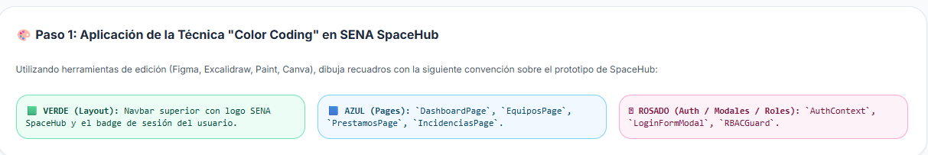
https://www.figma.com/design/bpTWQIjNEMqK5BFgkFTYUH/Sin-t%C3%ADtulo?node-id=0-1&t=x5BUL9uo7DBHUcqr-1

